UPDATE: Notification enhancements within the Auth chevron

Minor notification enhancements have been made within the auth chevron when Passport Authorizations cannot process a message.

Instead of displaying “No Data Available” when a message cannot be processed, users will now be presented with “Skipped By Rule” in the lower right corner along with a description as to why the message cannot be processed.

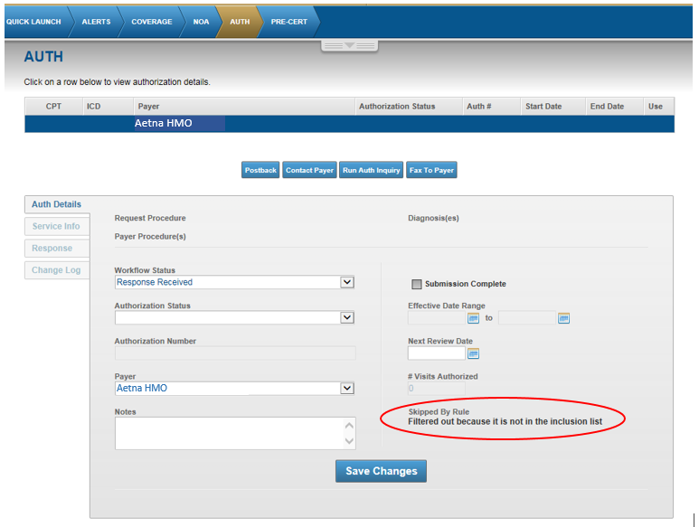

Sample (when Date of Service is missing or invalid):
Skipped By Rule
Filtered out because date of service is invalid

Sample (when Date of Service is outside of range to process):

Skipped By Rule
Filtered out because date of service is out of processing range

