ClaimSource

Release Features – 08/04/2016

Email Notification for Printer Service:

Under User Setup a notification can be set up to send an email notification to selected employee(s) if a print service goes down. If the print service is down for more than 5 minutes an email notification will be sent to the selected employees. The time span of the notification is customizable but, the default is set to one hour if the service is still down.
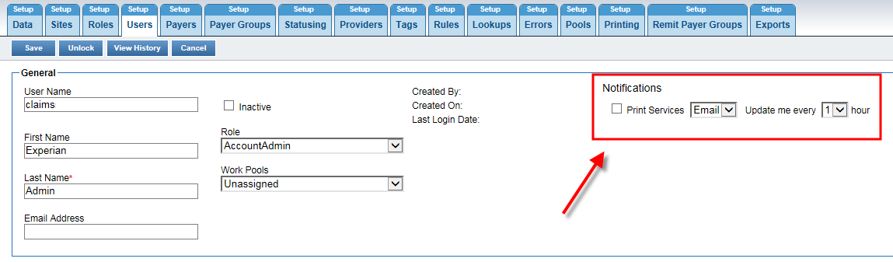

Remittance Filters:

Under Remittance ClaimSource added additional filtering features. The filters can be done at the remittance level or by a particular payment off the remittance.

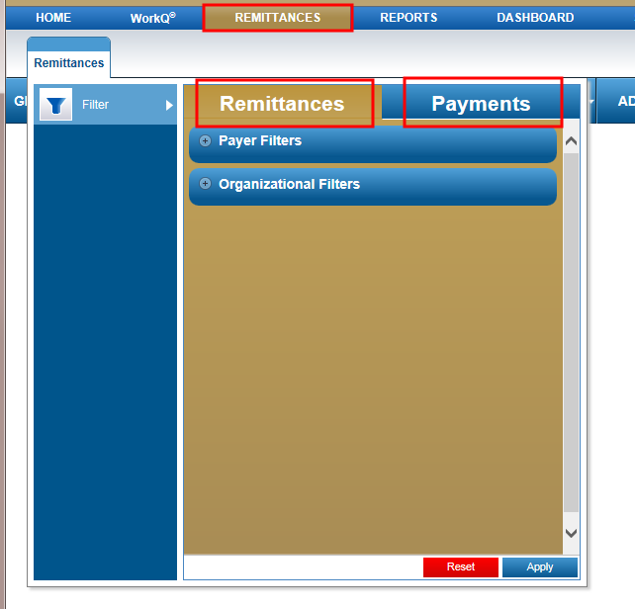
For Remittance it is grouped by Payer and/or by Organizational.
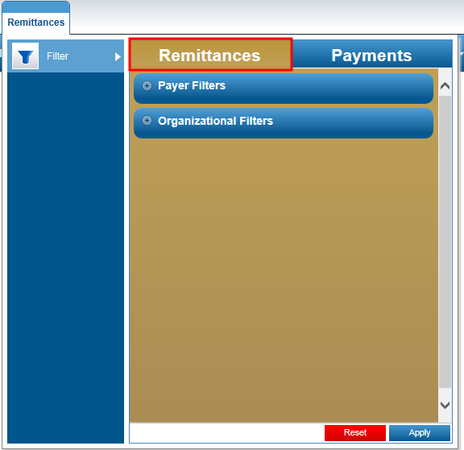

Payer Filter filters by Remit dates, Payers, Payment Type and Remit Number.
Organizational Filter filters by Provider NPI and Provider Level Reason Codes.

Under the Payer Filters a new feature has been add to filter by multiple Remit Payer Group or by Payer Name.
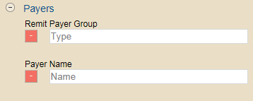

To filter by one or multiple enter the in the remit payer group or payer name and press the tab key.
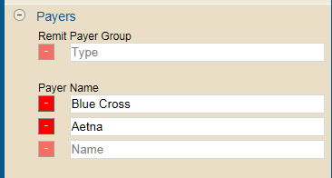
To Delete a payer or group click on the red box. This will remove the selection.

Notes:
- This multiple payer feature is only under the Remittance Filter.
- Remit Payer Group is a way to group remittance under one customized grouping. This is a new feature coming soon.
Under Payment filter it is grouped by Payer, Patient, Subscriber, Claim and Codes.
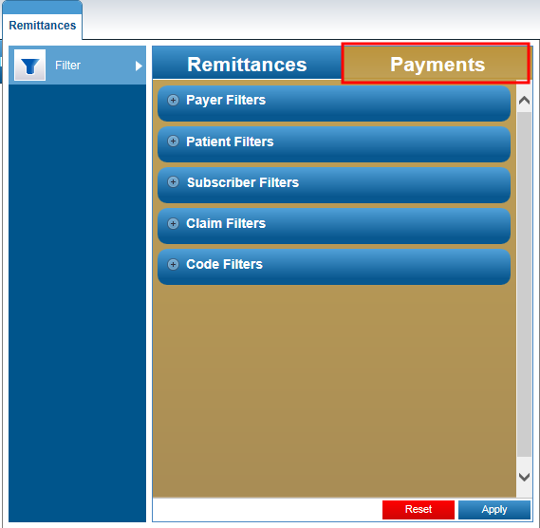

Payer Filters filter by Service Dates, Total Charges, Payment Amount, Bill Type and Payer DCN.
Patient Filters filter by Patient Control Number, Patient Last Name and Patient Type.
Subscriber Filters filter by Subscriber Last Name and Subscriber ID.
Claim Filters filter by With Related Claims or Without Related Claims. This is if a claim was or was not matched to the payment.
Code Filters filter by Reason Codes, Revenue Codes and HCPCS/CPT Codes.

