ClaimSource™

Release Features – 08/18/2016

Rename WorkQ to Claims:
With the addition of the Remittances feature and soon to be released Denial Management feature, the WorkQ feature has been renamed to Claims. The Claims feature works the same as WorkQ. Only the name has changed.

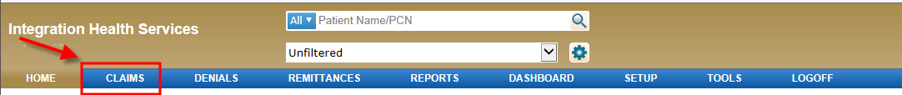

Views:
A side by side view has been added. This allows the user to look at two views side by side (provided your ClaimSource browsing window has sufficient width). The example below shows the claim view and the x12-837 view:

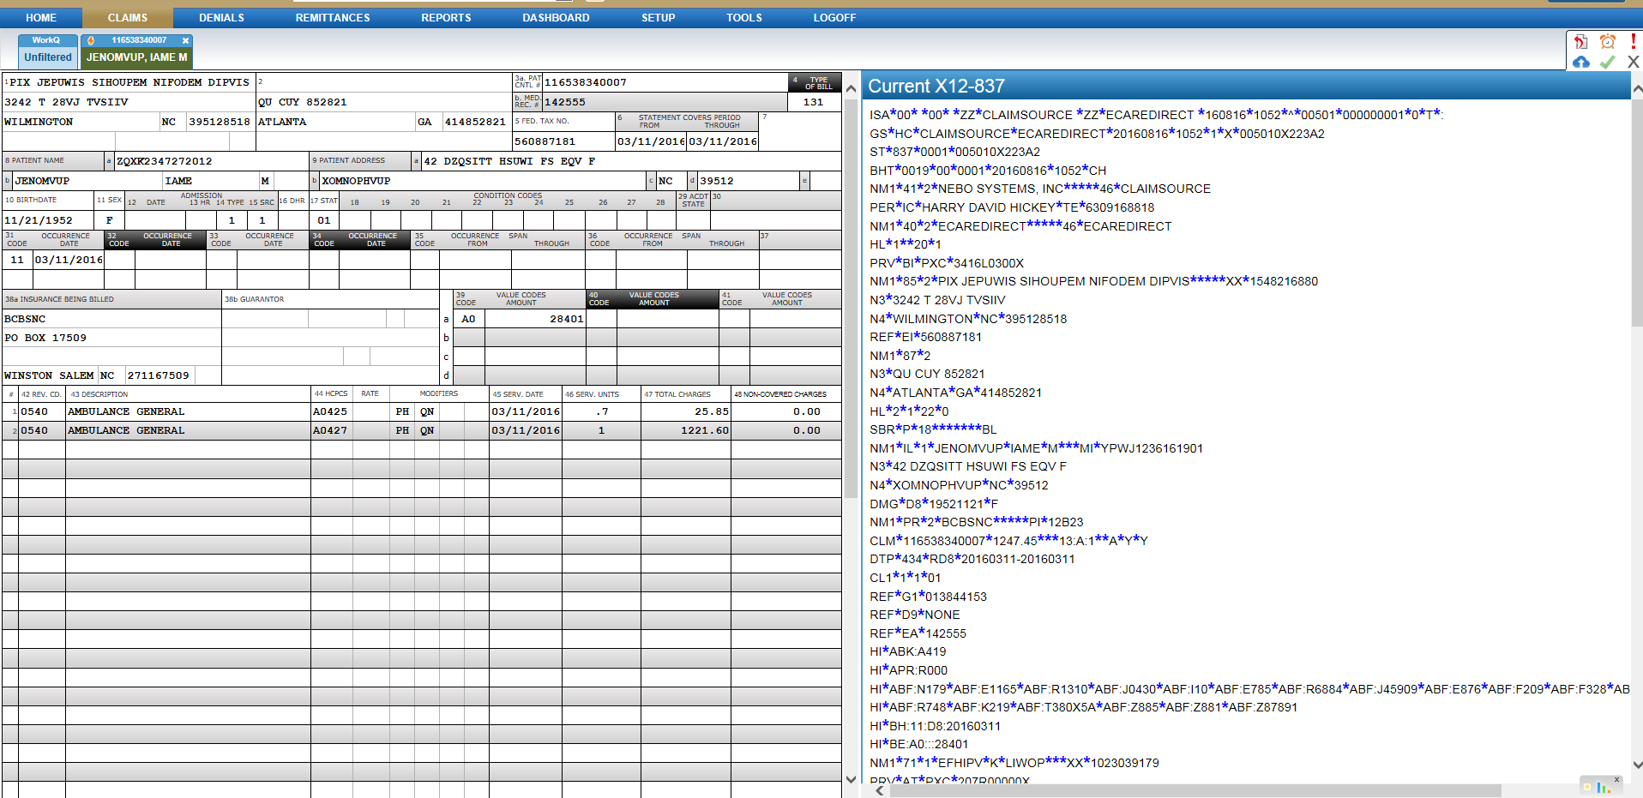

NOTE: Side by side view only works with the form and X12-837, submission log or payment views.

For side by side view with the X12-837 or Submission Log, click on tab to select Views and select X12-837 View or Submission Log.
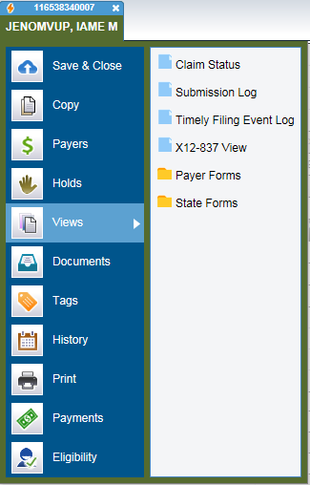

For side by side view with the payment, click on tab to select Payments and select the desired payment for viewing.
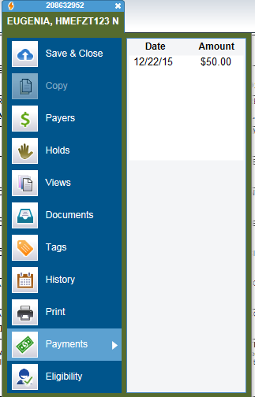

When the side by side view is enabled, a menu option will appear by hovering the mouse over the patient name on the claim’s tab. This will allow the user to close the second view and/or navigate back to the original form by clicking on the name.

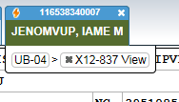

NOTE: If you only want the Imported and Current 837 views, after selecting the view, click on the X12-837 View button under the name to display them without the form (side by side or vertical depending on your ClaimSource browser’s width).

The main close button will close both views and return to the Claims WorkQ.
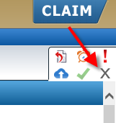

Payer Setup:
Under Payer Setup, select a payer and under Billing Info a field is renamed from 837 payer ID to HIS Payer ID. The HIS Payer ID is the ID set up in the clients host system and sent to ClaimSource in the 837.
