Dear Colorado Medicaid Providers,
On October 31, 2016 the Department of Health Care Policy and Financing will launch a new claims payment system, known as the Colorado interChange. As part of this transition, we have enrolled with the new system, and have a new Trading Partner ID.
Please follow the instructions below to log into your web portal account and authorize us as your trading partner. We cannot submit your Health First Colorado (Colorado’s Medicaid program) or Child Health Plan Plus (CHP+) claims or pick up reports on your behalf, until after you have completed this process.
Please note that these instructions are only for providers who are approved in the Colorado interChange. If you are in the process of approval, please save these instructions for use when you are approved. If you have not started the process to revalidate or enroll with Health First Colorado, please visit Colorado.gov/HCPF/Provider-Enrollment.
Please note also that all claims sent to CO Medicaid beginning on 10/31/16 should be sent using payer code 77016.
Step 1:
Login to the Provider Web Portal at https://Colorado-hcp-portal.xco.dcs-usps.com/hcp/provider.
- If you have not already registered for the Web Portal, please do so now.

Step 2:
Click “Manage Accounts” on the left-hand side of the page
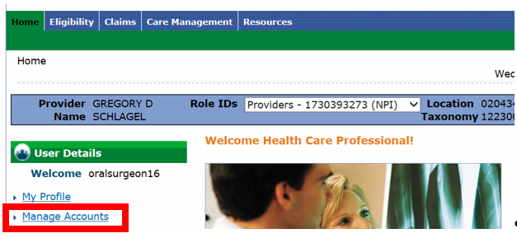

Step 3:
Click the “Add Registered Billing Agent/Clearinghouse/Switch Vendor” tab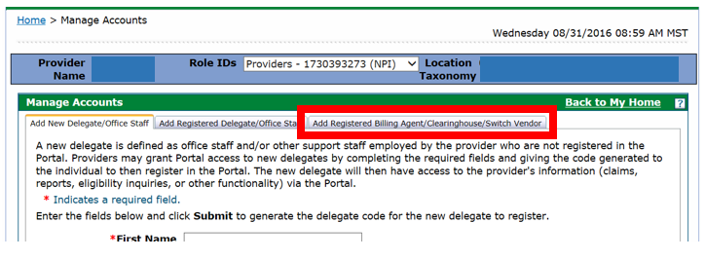

Step 4:
Enter 6981428 in the “Trading Partner ID” box and press “Validate Billing Agent”
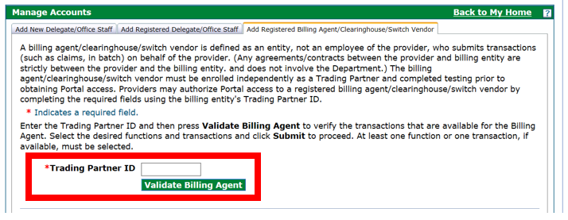

Step 5:
Please select the following functions and press “Submit”:
Alerts
Care Management - Submit Resubmit Authorization
Care Management - View Authorization
Claim - Inquiry
Claim - Submit and Resubmit
Claim - Submit Pharmacy
Enrollment
Member Focus Viewing
Payment History - Inquiry
Provider Maintenance
Secure Correspondence
Verify Eligibility

