ClaimSource

Release Features – 09/01/2016

X12 – 837 and Submission Log View:

X12-837 and Submission Log view can be seen in a table format with X12-837 loops and segments identified for a more user friendly view as well as formatted and unformatted raw X12-837 transaction. Choose the appropriate view from the claim tab. The default X12-837 view is the table view.

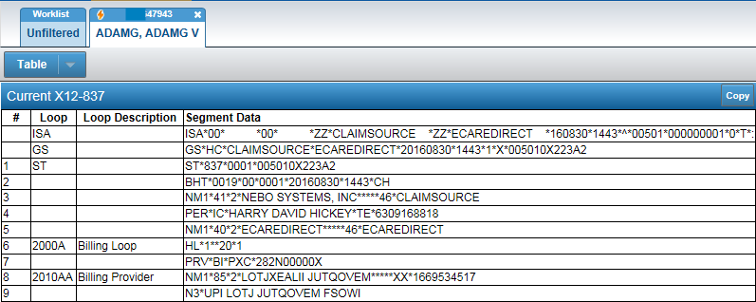

To change the view format click on the down arrow for a list of formats.
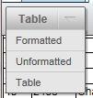

Each view has a copy button. The copy function will copy to a clipboard. This will work in any browser.

Profile Manager:

To create a new profile a drop down list is available to select the type of profile a user wants to create. The options is Claims profile to build a work queue based on claims, Alerts profile to build by the errors/alerts and a Denial Profile for a new Denials Manager feature.

To create a new profile click on the down arrow to select the preferred profile.

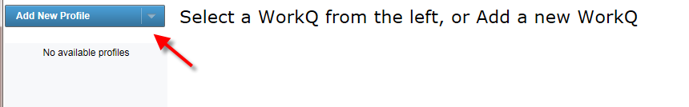

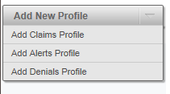

The selection criteria options for work queue profiles have not changed.

NOTE: The denial profile will only show for those clients that have the Denials Manager feature.

A default profile can be set by clicking the star next to the profile name under Profile Manager. This profile will be the default work queue loaded when clicking on Claims tab.
