ClaimSource

Release Features – 10/06/2016

Work Queue Icons:
With the addition of multiple work queues, ClaimSource added action icons to display the type of work queue built.

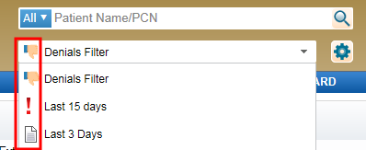

= Denials Work Queue

= Alerts Work Queue

= Claims Work Queue

