ClaimSource

Release Features – 12/08/2016

Reports: New Email Notification:
For scheduled reports an email notification can be set up. For reports with non-PHI information the report can be attached to an email. For reports with PHI information a link will be sent to login into ClaimSource to pull the report.

To set up this feature an email address must be entered on the user profile.
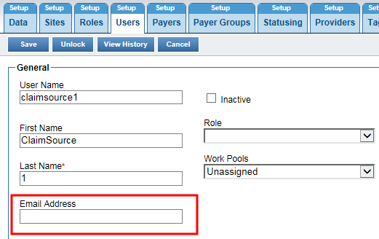

Under Reports email notification is set up for scheduled reports only. When scheduling a report step 4 is to Add Notification. The user can check on send email notification. This can be done with a copy of the report or without a copy. All reports with PHI information will be set as without copy and the email will have a link to sign into ClaimSource to pull the report. For non-PHI reports these can be set as with or without a copy of the report within the email. The format of the report can be excel, PDF or CSV based on the option chosen on step 2.
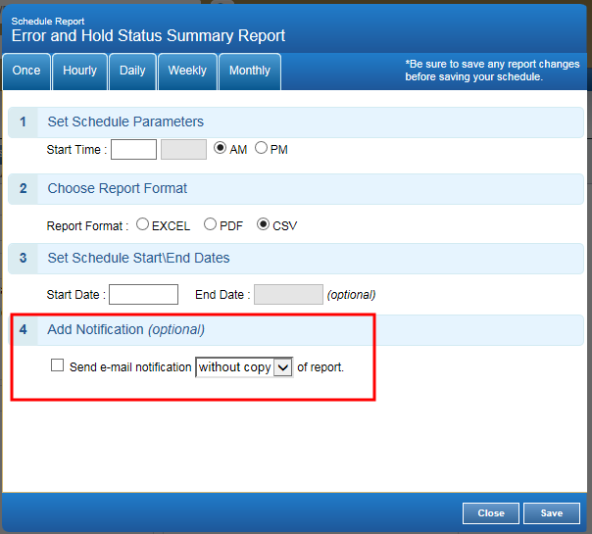

Reports: New Quick Search
Under Create Report a Quick Search field is added for ease of lookup for a report. In this field start keying in a word or phrase and the search will start matching on that information.
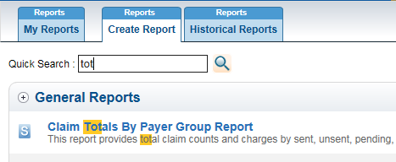

Reports: New DDE FISS reports:
ClaimSource has the ability to pull in data from the 201, 56 and FI DDE reports. There is set up required for this feature. Please contact your ClaimSource Account Manager if interested in learning more about receiving these reports via ClaimSource.
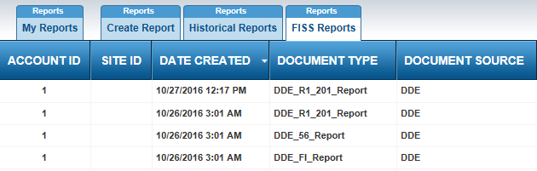

Update to Patient Name Search for Claim and Alert Filter:
For Patient Name search the From field can be used as a full name search field instead of a from and to.
In the From field the user can type in Lastname, Firstname to search for a specific patient.
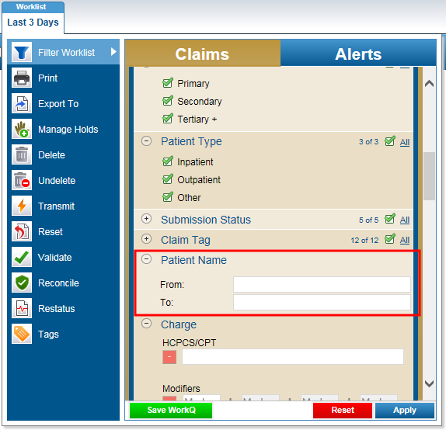

New Claim and Alert Filter Options:
Two new filter options have been added; Modifiers and DRG.

The modifier search can be searched by multiple modifiers on the same charge line or on different charge lines.
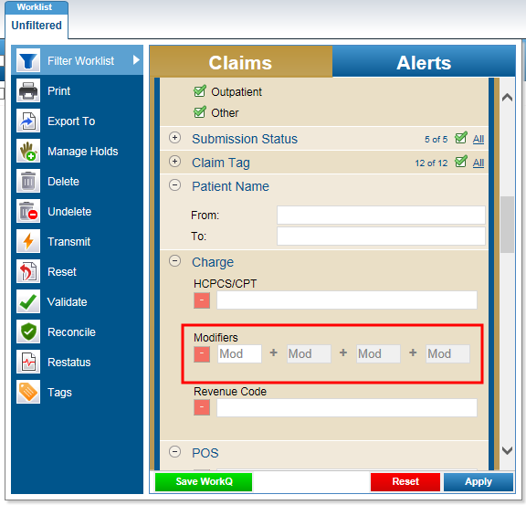

To search for modifiers on the same charge line, enter in the multiple modifiers for that charge line on the same line in the filter.
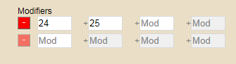
To search for modifiers on separate charge lines, enter in the modifier on the first search line. Once a modifier is added a second search line will appear. Enter the different modifier for a different charge line on the second line.
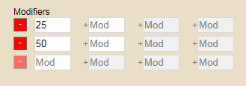

DRG filter is added under Diagnosis. This is for a single DRG lookup
