ClaimSource Release Features – 1/5/2017

Updated: Form View
Under the Claims Context Menu, Forms are now a separate option. Forms are no longer under the Views Options. On a claim click the tab to bring up the context menu and click on forms.

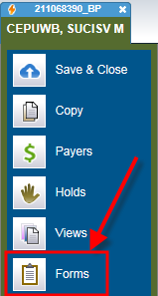
This will display the new form box for easier view and selection of forms.
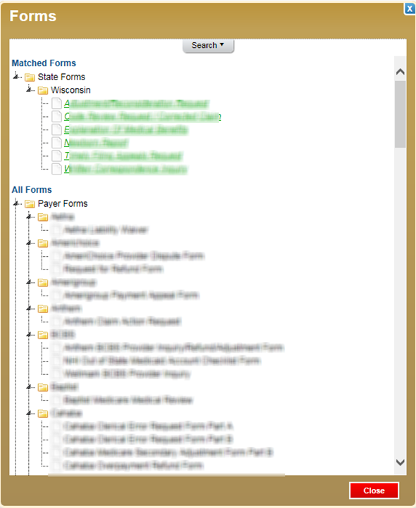

The Forms window has a Matched Forms and All Forms sections. By default the Matched Forms section will show the forms associated with the state of the payer. If the patient resides in a state different from the payer it will show those forms as well. The second section is All Forms. This will list all forms available for the client.
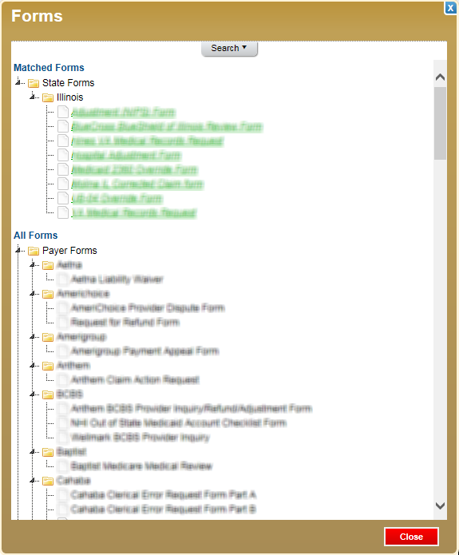
A search tab is located at the top. Click on Search to expand the selection criteria. The search options are; Form Title, by State, Form Types (ex: Appeal) or by the Payer Filing Indicator within ClaimSource. This search criteria entered will appear in the Matched Forms section.
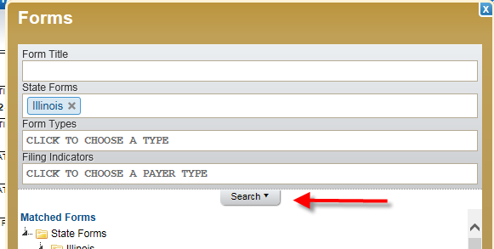

Added: DDE Submission Views
For those clients using the DDE Submission feature there is now access to view the info entered on the DDE screens. The DDE screens shots are located under the Views options and choose DDE Submission.
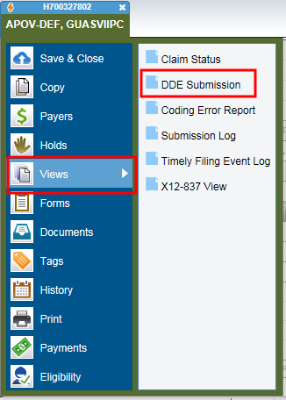
Scroll through the view to see all screens.
