ClaimSource Release Features – 2/02/2017

Added: New Remit Payment Filters
Two new filter options have been added; Med Rec # (Medical Record Number), Payer DCN.
In addition, the Subscriber ID Filter has been renamed; Subscriber ID/HICN.

Payer DCN search is added under Payer Filters within the Payments Tab. This is for a single Payer DCN lookup.
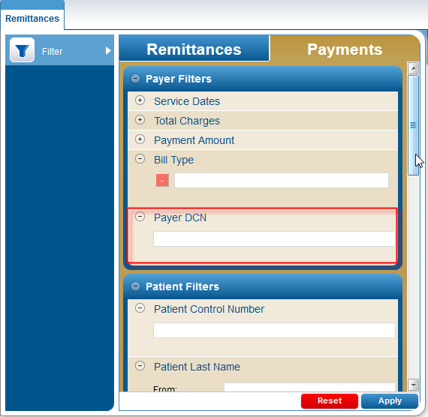

Med Rec # search is added under Patient Filters within the Payments Tab. This is for a single Med Rec # lookup.

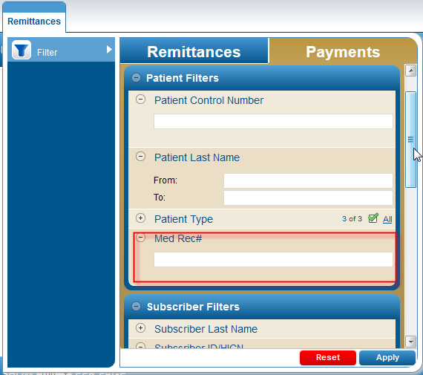

The Subscriber ID Filter has been renamed to Subscriber ID/HICN.

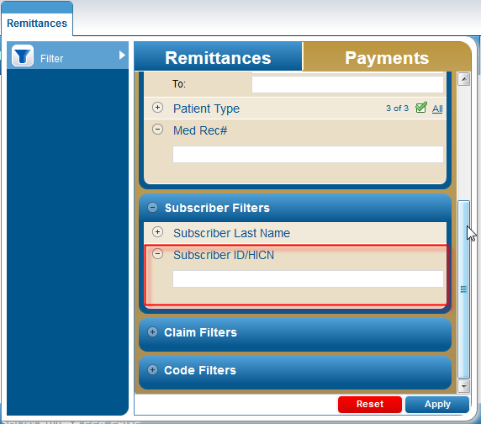

Updated: DDE Submission Views
For those clients using the DDE Submission feature, the DDE screens have been moved. The DDE screens shots are now located under the Views options then choose Submission Log.
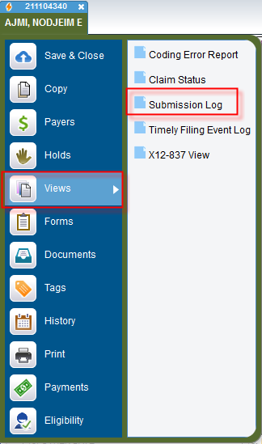

When a DDE Submission Log View is available, a View DDE button will be displayed next to the Transmission information.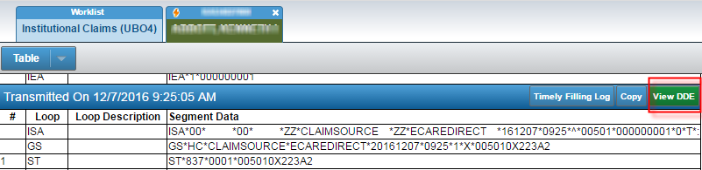

Clicking on the button will scroll through the view to see the DDE Screen.
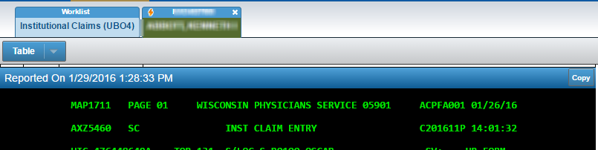

Added: Search Header takes into account if user is in the Claims, Remittances or Denials Tab.
When performing a search at the header, it now takes into consideration the Claims, Remittances or Denials tab position.
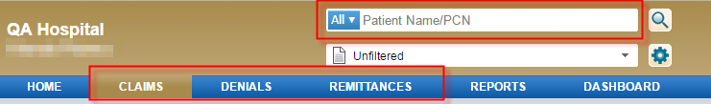

For example, using the search while under the Remittances tab, will search within that Remittances tab.
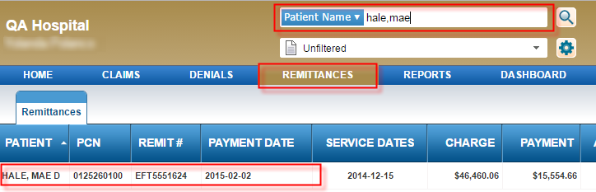

Added: Reason Code Column is now available within the Denials Workqueue
For those clients using Denials, the Denial WorkQ Column Settings has a new column called Reason Code.
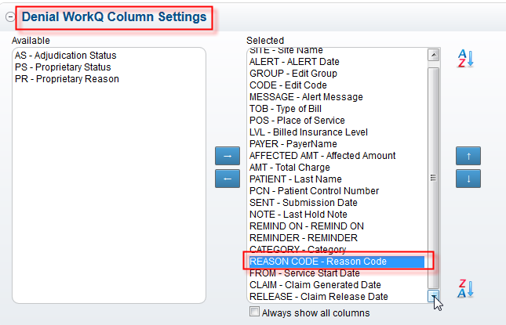

The reason code column will be displayed within the Denials WorkQ in the location selected by the user.
