ClaimSource Release Features 2/16/2017
Updated: ClaimSource is updated with a new look and feel that reflects the new color scheme and logo of Experian’s rebrand effort. All of ClaimSource features that you currently enjoy are still available, but you may find the font and buttons look slightly different.

Below is an example of the new color scheme. Please note that all of the functionality remains the same.
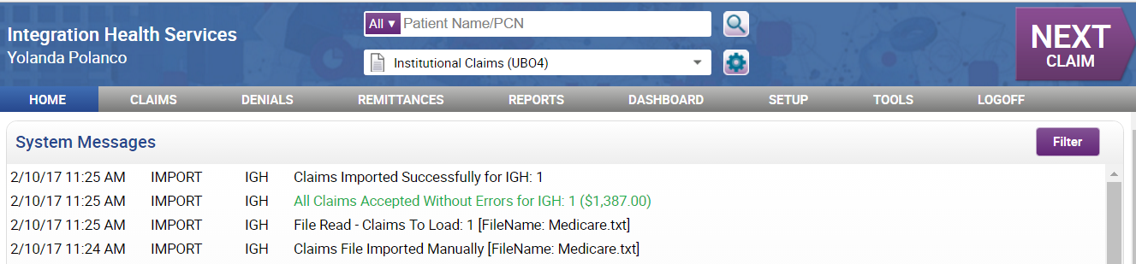
Within the claims work list, sent claims are still displayed as green, and locked claims are displayed in red.
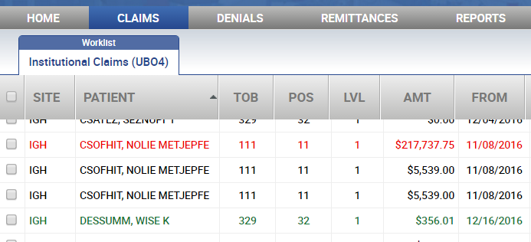

All windows have been updated. Some buttons have been updated with our newest color.
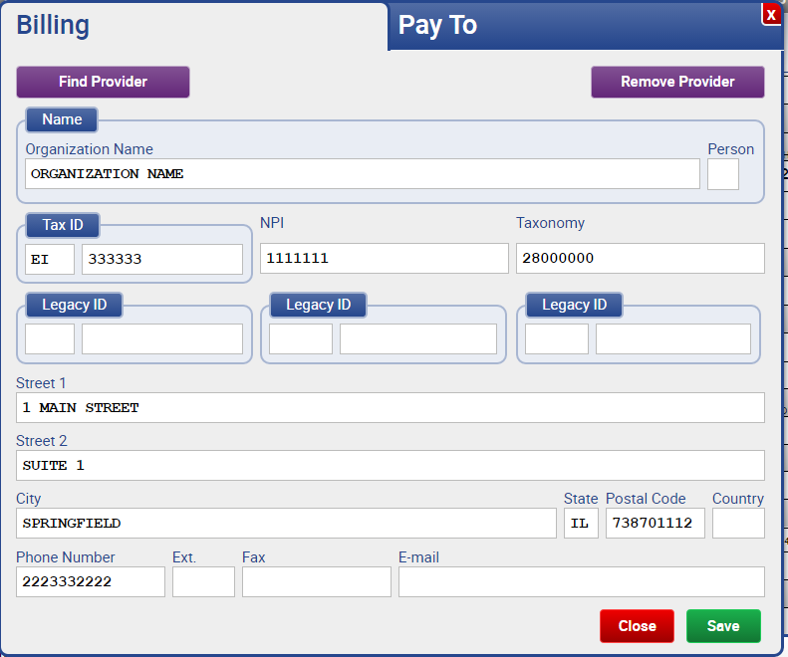

The error panel colors remain the same. Errors and Holds did not change in color; Errors are red and Holds are yellow.
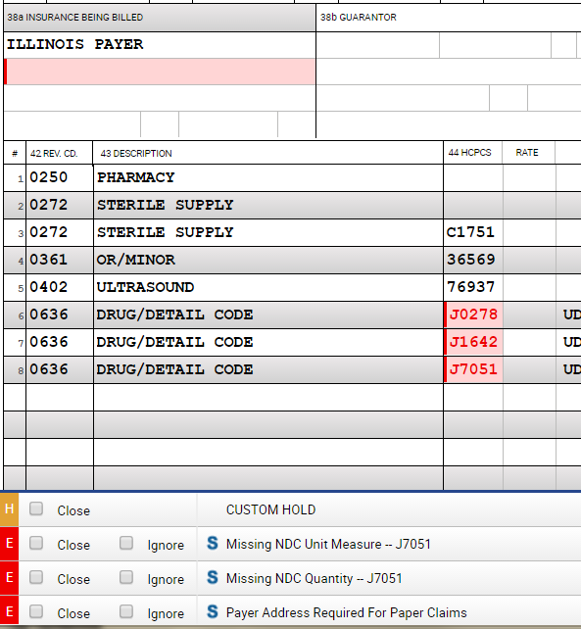

Added: New Source Error Panel Icons
We have added new source icons within the error panel. Below are the descriptions:
Lightning bold icon = Errors with EditCode beginning with XTRANSMIT are Experian Health clearinghouse errors.
"P" icon = Errors with EditCode ZCLHRGEN are reconcile/payer or third-party clearinghouse errors.
"C" icon = Errors with EditCode that begin with "c", excluding "COPY" indicate custom edit errors.
"S" icon = Used if above criteria are not met and means standard edit.

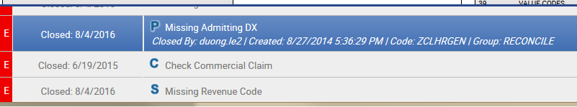

Added: Remittance Detail Report added to Remittance Menu
For those clients using Remittance, the Remittance Detail Report is accessible using the Remittance menu.
