ClaimSource Release Features 3/02/2017

Added: Ability to export the raw 835 data from the Remittances Tab.
For those clients with Remittances, a permission-based functionality to export the raw 835 data is now available. The permission “Remit Export 835” is located within the Setup Roles tab. When a user has the permission, the new 835 data column is displayed within the Remittances worklist.

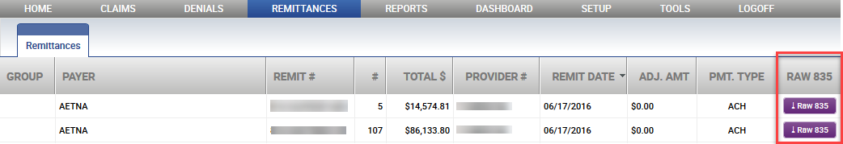

Clicking on the Raw835 button will prompt the user with two options: export a merged file of all associated 835’s, or only the single 835.
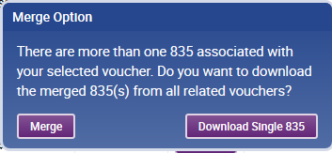

If the option of Merge is selected, the user has an additional option of adding line breaks after each segment for easier viewing.

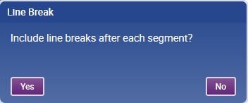

Added: Setup User Export Option
Users now have the ability to export the user list to excel or a csv file. It is available by accessing the Users menu.
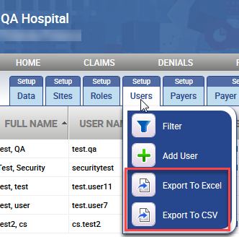

Added: Status Reports have an option to sort by Status Group
The Claim Status Detail Report and Medicare Claim Status Detail Report can now be sorted by status group. In addition, a Status Group Column has been added to the reports’ output.
