ClaimSource Release Features 3/16/2017
Added: Set a user’s preferred time zone
The time zone is set based on each individual user’s preference. If a time zone is not specified, the time zone will be defaulted to Central Time (CST/CDT).
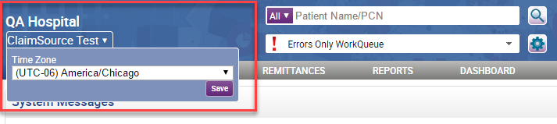

Managers can also set a user's time zone by going to the Users tab in Setup. A quick option, Use Mine, is available to set the users time zone based on the manager’s own, if it is set, if not, it will use the browser’s settings.
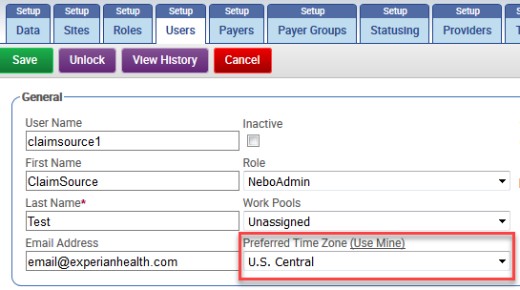

Updated: Reports Date Range Parameters Location
Date range parameters are now located at the top of the criteria selection for all applicable reports.
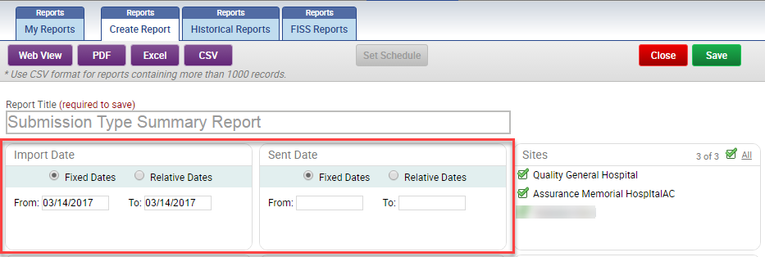

Updated: Date Range Default
The first date range parameter is now defaulted to the current date.
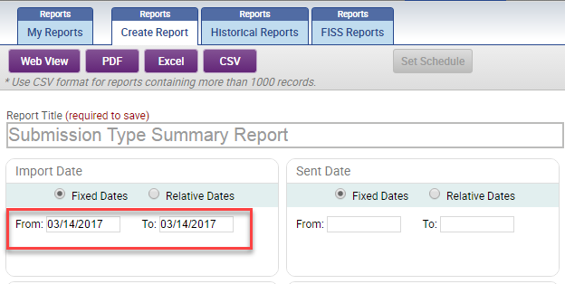

Added: Ability to See Current Progress on Automation or Batch Jobs
When an automation or batch job is in process, a System Processes section will appear collapsed on the Home Screen. The following jobs in ClaimSource will be displayed in the System Processes section: Batch Print, Batch Reconcile, Batch Status, Batch Transmit, Epic Export Files, Export 837, and Import Claims.
*Please note that small jobs may occur too fast to see any progress.
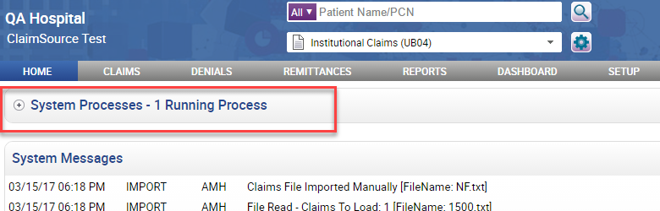

The section can be expanded to better view the current running processes by clicking on the plus sign.
The section can be collapsed by clicking on the minus sign.
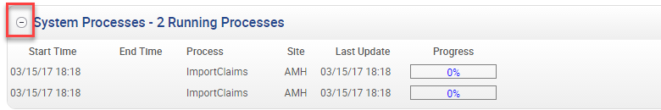

The system processes section can be refreshed by clicking on the refresh button.
