ClaimSource Release Features 3/30/2017

Added: Ability to Print Eligibility Request
For those clients with eligibility, there is a new option for printing the request within the eligibility window.
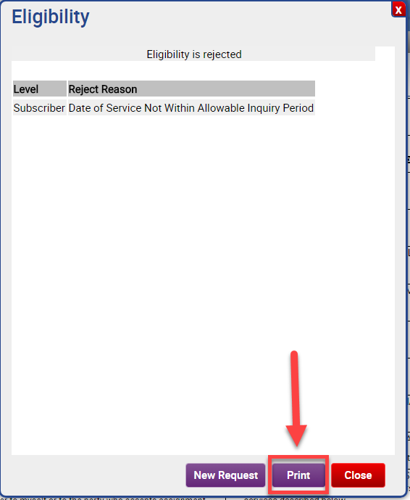

After clicking the print button, the user will be directed to a new tab with the information they will be printing.
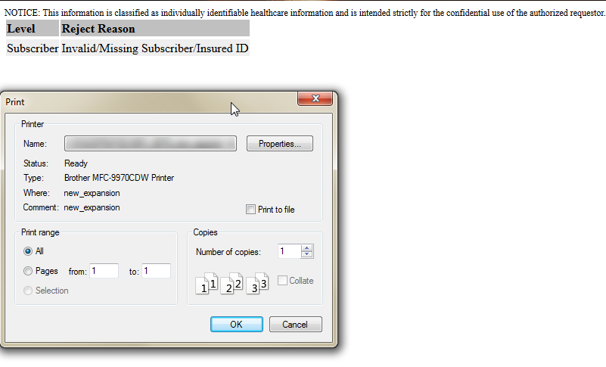

Added: Work Queue Filter by History Event Code and History Event Message
The following two searches have been added to the Search Filter: History Event Code and History Event Message. Both Event Code and Event Messages are found in the Claim Change History window.
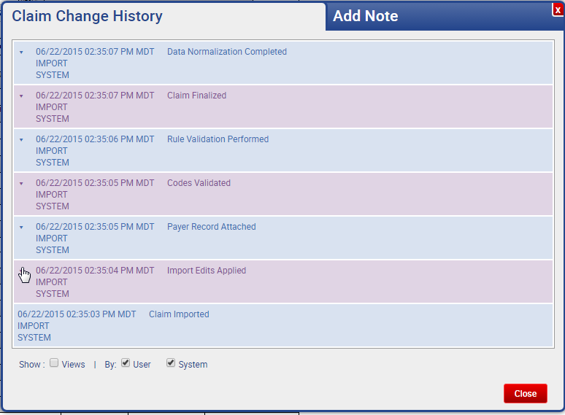
The history event code search is an exact match search. The history event message performs a Begins With search.
Note: A wild card of % can also be used to search. For example, searching for an event message of %value% will search for claims that include value anywhere in its event message.

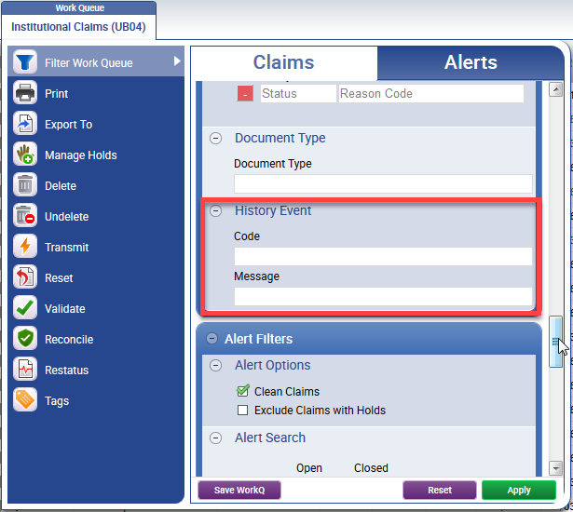

Updated: Claim Status Menu Option Has Moved
In the Context Menu, the Claim Status option has moved from Views to its own selection.
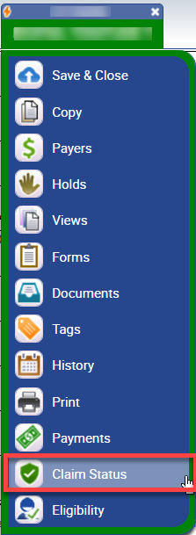

Added: Time Zones in Scheduled Reports
User’s time zones are now reflected in their scheduled reports.
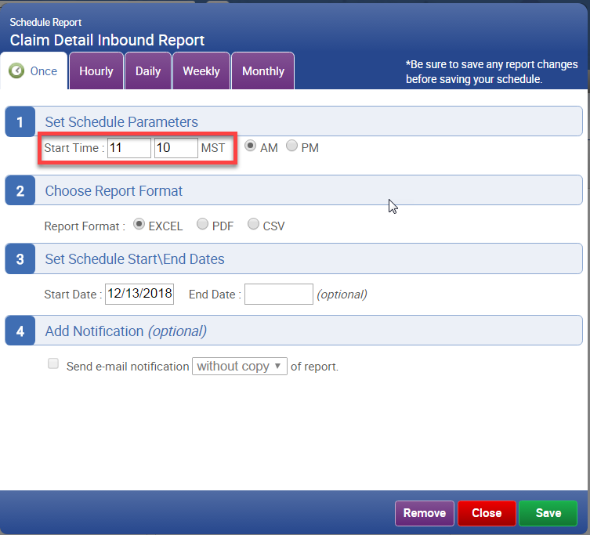

Updated: Warning Added when Resetting a Claim Sent to Payer
Users will now be warned when they try to reset a claim that has already been sent to the payer.
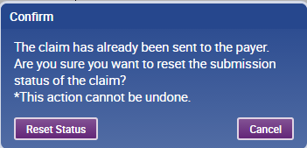

When a user click on the Reset Status button, the user will see the following progress window. This will force the action of reconciling the claim for the user.
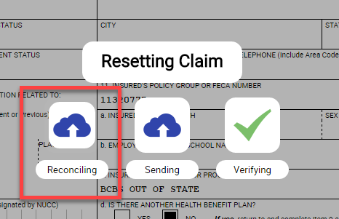

If a claim is reconciled with a status of Rejected, resetting of the claim is not performed and the claims submission’s status is updated.

