February 27th 2017
RQA AlertBuilder Tool Update
Next Thursday, March 2nd 2017, two AlertBuilder functions related to date operations will be replaced by four functions to provide more flexibility.
Here are the 4 new operators:
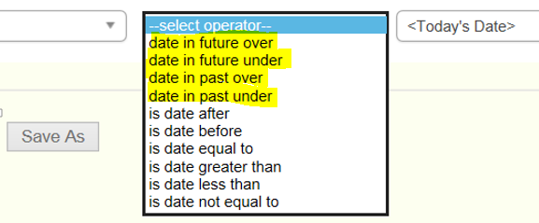
Any existing old alerts that are using the previous functions, will be automatically updated with the new names on Thursday. The functionality will remain the same.
The table below gives a brief description of the old and new operators.
Old Function | New Function | Definition
time exceeded | date in past over | The date in the past is older than current date by specified time range. (X no. of days, month, or years)
time not exceeded | date in past under | The date in the past is within a specified time range. (X no. of days, month, or years) to the current date
 | date in future over | The date in the future is farther than current date by specified time range. (X no. of days, month, or years)
 | date in future under | The date in the future is within a specified time range. (X no. of days, month, or years) to the current date

Here is an example for each case:
Example | Description
DischargeDate date in past over 5 days | If current date is 5/10/2017 and DischargeDate is 5/4/2017, the condition is true and alert fires.
DischargeDate date in past under 5 days | If current date is 5/10/2017 and DischargeDate is 5/6/2017, the condition is true and alert fires.
DischargeDate date in future over 5 days | If current date is 5/10/2017 and DischargeDate is 5/16/2017, the condition is true and alert fires.
DischargeDate date in future under 5 days | If current date is 5/10/2017 and DischargeDate is 5/14/2017, the condition is true and alert fires.

Example of current alert that is using the ‘old’ operator:
