ClaimSource Release Features 4/13/2017

Added: Ability to scroll tabs using tab buttons
New tab buttons will appear when the number of opened tabs exceed on screen display. A user can click on the buttons to scroll from left to right or vice versa. This new feature applies to Claims, Denials, Remittances and Setup screens.
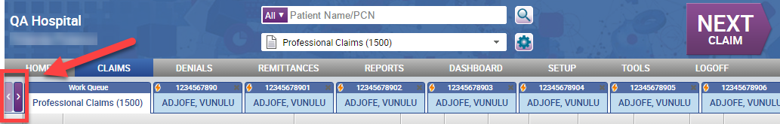

Updated: Provider Usages is a list
Users now only have to click one save button for both the Provider Lookup and the Provider Usages. Provider usages are now displayed as a list for easier viewing.
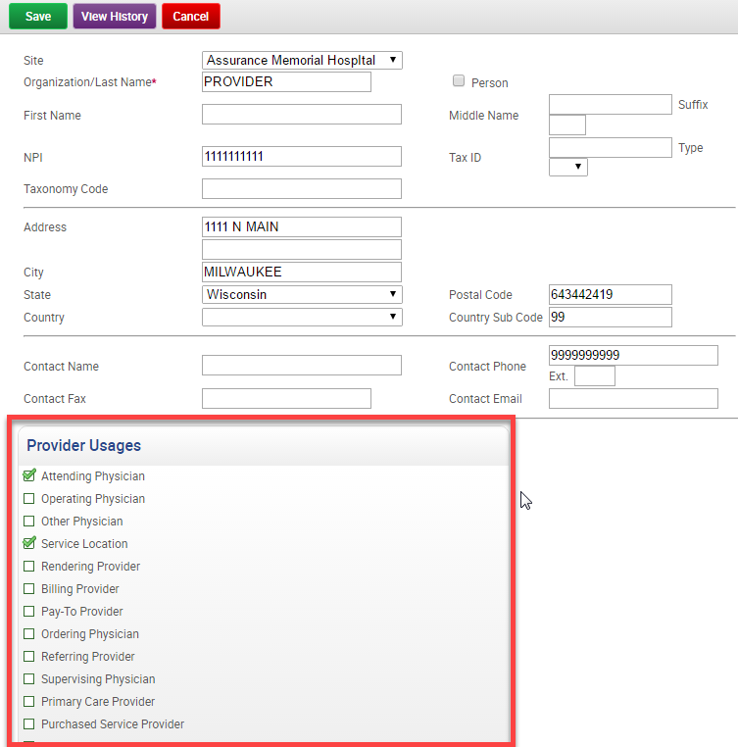

Added: Opening Multiple Claims
Users now have the ability to open up to 10 claims at a time. This action can be found within the work queue’s batch action menu. Users must select the claims first using the checkboxes to the left of claims, followed by clicking on the Open Claims action.

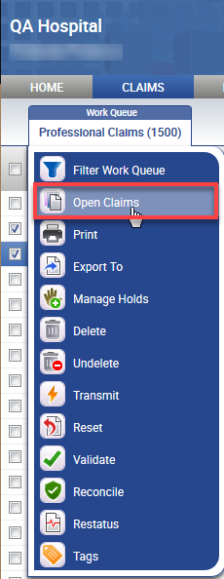

If a user attempts to open more than 10 at a time, they will see the following alert window.
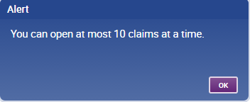

Added: Billing Payer Country drop-down
The Payer setup screen now shows a billing payer country drop-down.
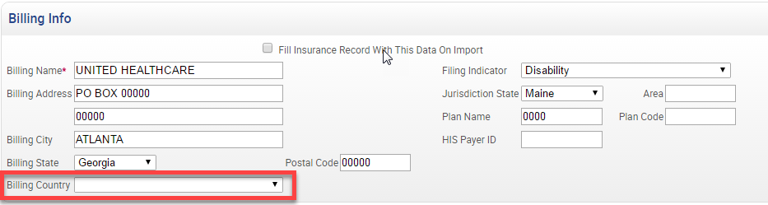

Added: CPT Column in the Denials Work Queue
For those clients with Denials, a new CPT column has been added in the work queue. The CPT Column can be customized using the denial work queue column settings within the work queue manager.
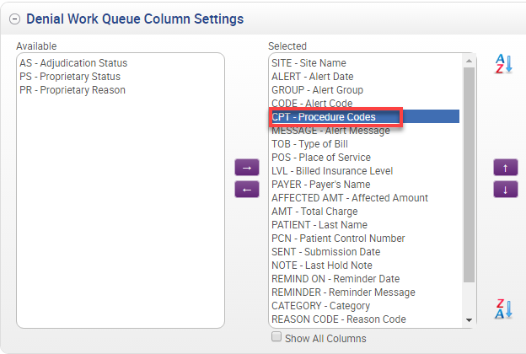

Added: Submission Type Summary by Payer Report
New report allows users to see the electronic submissions by EDI Transmit ID. The new report is located under the Submission & Status Reports section.
