ClaimSource Release Features 4/27/2017

Added: NY Medicaid Tab for NY Medicaid 150003 form
A new tab is available for New York Medicaid. It is visible when a billable payer filing indicator is MC and if the billable payer state is set to New York (NY). The NY Medicaid tab is located within the Claim Lookup, which can be accessed by double-clicking on the Patient Control Number Field or any other claim-level field.
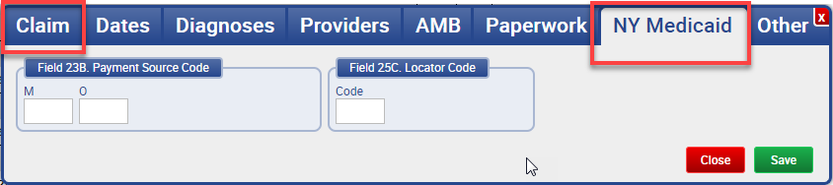

Added: New Denial Productivity Summary Report & New Denial Productivity Detail Report
For those clients with Denials, there are two new reports within the Denial Manager Report Section: Denial Productivity Summary and Denial Productivity Detail reports.
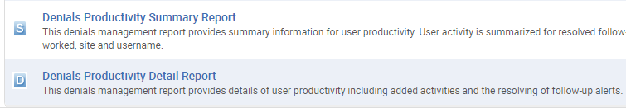

Added: Ability to Select Institutional or Professional Claims for Status Groups
In the Statusing tab located in Setup, two new checkboxes, Include Institutional Claims and Include Professional Claims, are now available for status groups.
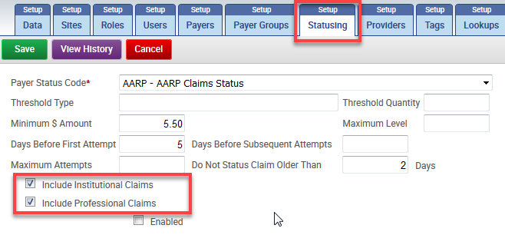

Added: Ability to Filter by Root Cause and Physician have been added to the Follow-Up Alert Detail Report
The follow-up detail report can now filtered by root cause and will be shown in the output.
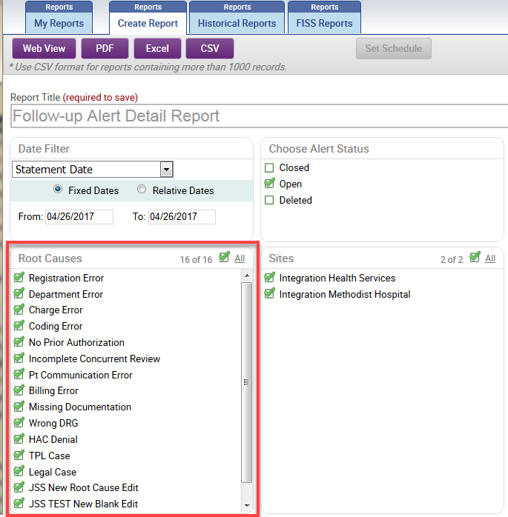
Physician filtering was also added and will be displayed in the output.
