ClaimSource Release Features 5/11/2017

Added: Previous button added to Claims, Alert and Denials Work Queues
A Previous (PREV) button has been added to the claims and alert work queues. For those clients with Denials, it is also available for the denials work queue. Clicking on the PREV button, will open the previous claim on the user’s work queue.
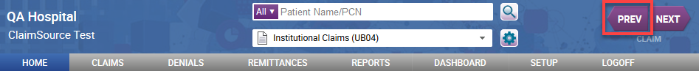

However, users must first open a work queue before clicking on the PREV button. Clicking the PREV button outside of either a claims, alert or denials work queue, will prompt the user with the alert shown below:
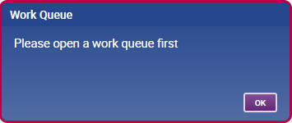

Updated: Next button has a new look.
The Next button has been updated with a new look. The button’s functionality remains the same. The Previous and Next button’s footer will be updated to reflect the type of work queue opened.
The footer will display, Claim, if a user has a claims work queue opened.
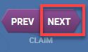

The footer will display, Alert, if a user has an alerts or denials work queue opened.

Added: News Section on Homepage
Messages from both Experian and from within the user’s organization can now be added to the homepage news section.
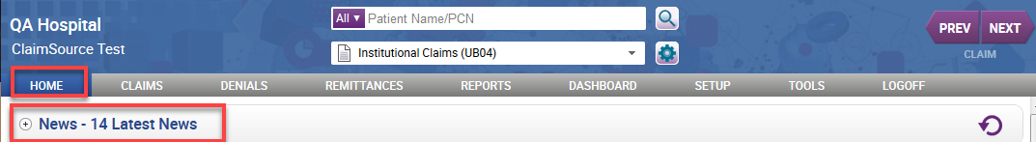

The news section can be expanded or collapsed by clicking the plus/minus sign to the left of the news section. In addition, a user may click on the refresh icon available to the right of the section for the latest updates.
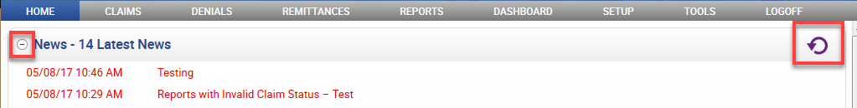

News items from Experian are labeled with a source of Experian and include the Experian logo next to the subject line.
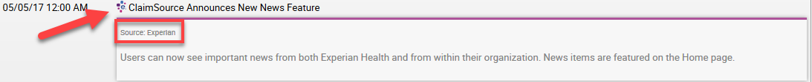

News items from the user’s internal organization are labeled as internal.
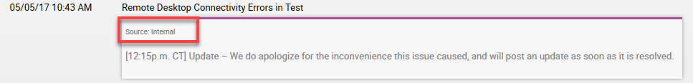
Important news items are displayed with red font and remain on top of the news section.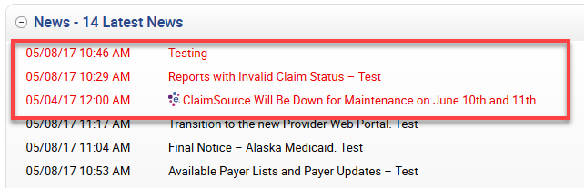

A user with the role’s permission of Setup Account News has the ability to add news items using the Accounts News tab.
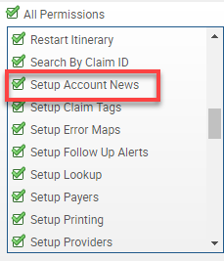
Users must click on the Add button to enter a news item and fill out the required information. The subject character limit is 125 and the content character limit is 8000. The news items expire at 11:59 PM Central Time of the day selected.
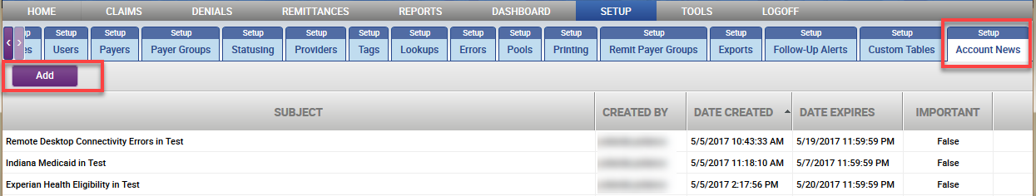

Added: Search Filter has a new Special Option
A new search filter, Exclude Claims with Future Reminders, has been added and is located in the Claims Special Options section. By selecting this option, a user is able to exclude items from their work queues that have reminder dates set in the future.
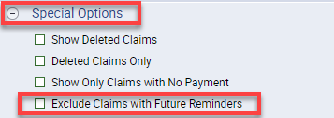

Added: Denials by Payer Summary Report
For those clients with Denials, a Denials by Payer Summary Report has been added. The new report allows the user to get summary denial counts or charges by payer.

