ClaimSource Release Features 5/25/2017

Added: Users can resubmit & print final submitted claims
When a user chooses to print final or pdf final on submitted claims, the prompt Printing a Submitted Claim is displayed with the options Resubmit & Print Final or Print a Copy.
When the user selects the Resubmit & Print Final option, it will reset the submission date and print the claim. When the user selects Print a Copy, it will re-print the originally submitted claim without any changes to the submission date.
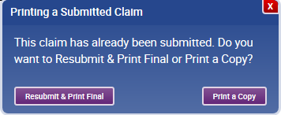

After selecting the option to Resubmit & Print Final, a second prompt will be displayed asking the user to confirm the resetting of the claim. If they select Reset Status, it will proceed with both resubmitting and printing the claim.
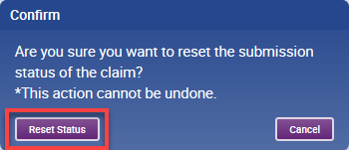

If a user chooses to Cancel the request, both the resetting of the claim and the print request are canceled. The user is alerted with the message below:
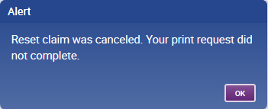

Added: Permission-based ability for users to update own email address and phone number
The ability to modify one’s own email address is only available for users with Permissions to Edit Users. It is located on the preferences section which can be accessed by clicking the user’s name.
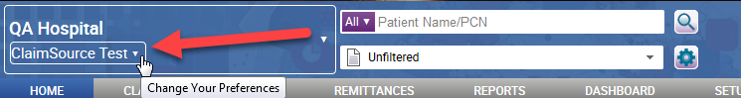

Expanding the window will display the email address and phone number fields. Phone numbers must have a format of 111-222-3333 and cannot be deleted.
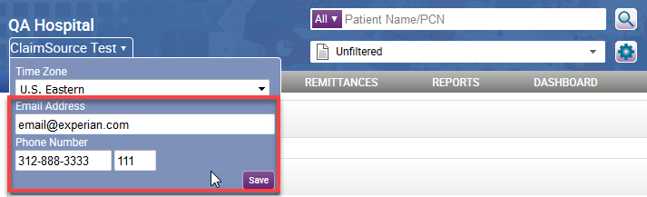

Added: Phone Number field for setup users screen.
A field for phone number has been added to the Setup Users Screen.

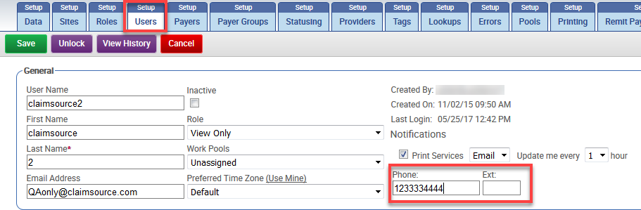

Added: Delete option for attached documents
The ability to remove uploaded documents is now available in the Documents Lookup. Clicking the Remove button located next to a user uploaded document will remove the document. A history event will be logged indicating the document deletion.
Please note: System generated documents cannot be deleted.
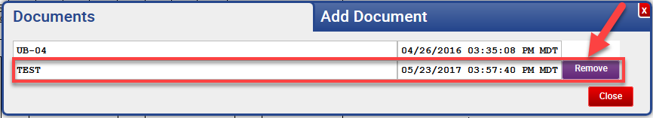

Added: New printer status icons are shown on the printer list
Printer status icons are now displayed on the claim’s printer list. The icons will only be displayed if there is an issue with the printer.
Red exclamation = Printer is not accessible by Service or Network Name is wrong
Yellow exclamation = Printer is offline
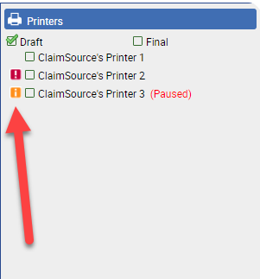

For users with access to the Setup Printing screen, the print service icons have been updated with a new look. Unlike the claim’s printing list, the icons on the setup printing screen will always be displayed.
Red exclamation = Printer is not accessible by Service or Network Name is wrong
Yellow exclamation = Printer is offline
Green Checkbox = Printer is online
Added: Printer States are shown on the printer list
The states of the printer are now reflected on the claims printer list, it will be shown in parentheses to the right of the printer name.
The following are examples of the possible states that may be displayed: "Door Is Open", "In Error", "Initializing", "Not Available", "Out Of Memory", "Out Of Paper", "Output Bin Full", "Paper Jammed", "Paused", "Toner Low", "Processing", "Queued", "Waiting", "Warming Up", and "Has Paper Problem."
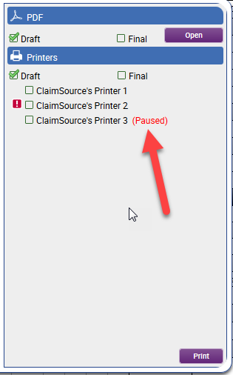

Updated: Distinguishable mark on locked claims
When a claim is locked by another user regardless of submission status, the tab’s top bar will be displayed in red.
Locked sent claim:
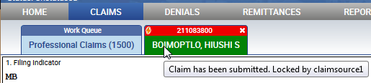

Locked unsent claim:
