ClaimSource Release Features 6/08/2017

Updated: Selected Denials Filters are now a checkbox.
For those clients with Denials, the filter for Categories, Protocols, Activities and Root Causes have been updated to a checkbox.
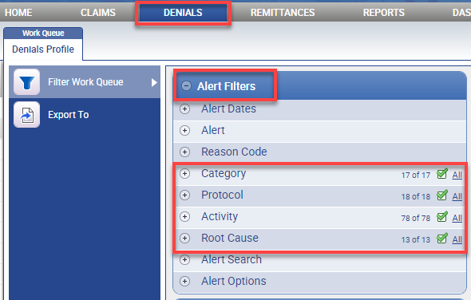

Users will be able to include or exclude items by selecting the checkbox next to the available options.
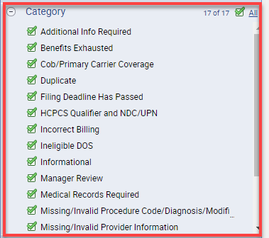

Updated: Setup Account News will display expired news with a strikethrough
Users with permissions to Setup Account News will see expired news displayed with a strikethrough.
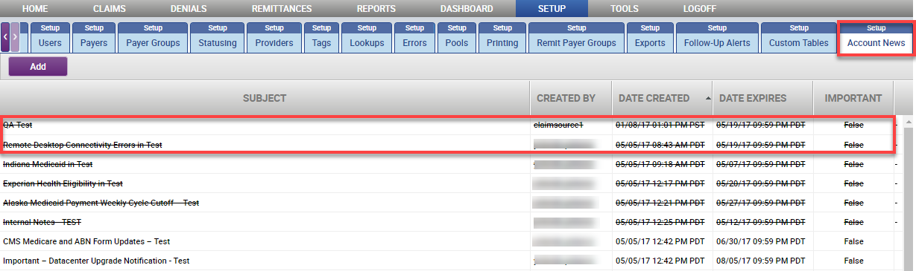

Updated: News section will remain expanded when items are selected as Important.
The news section on the homepage will remain expanded until all important news items have expired. News items are selected as Important in Setup Account News.
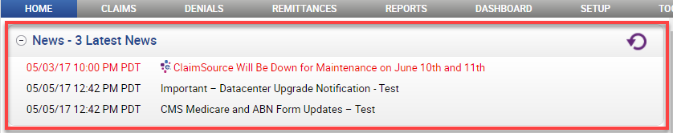

Updated: CAS window displays procedure code next to modifier fields.
In the charge level CAS tab, the location of the Revenue code and Procedure code fields have been switched. The procedure code field is now located besides the modifier fields.
