ClaimSource Release Features 6/22/2017

Updated: News section will not be displayed if no news are available.
If there are no news available, the news section will be automatically hidden.
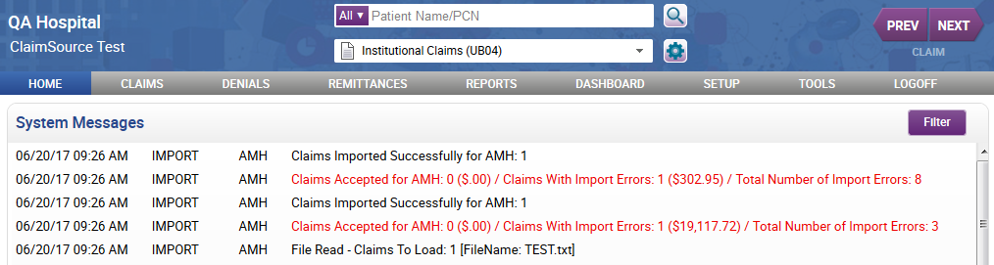

Added: Denials payer group work queue filter
For those clients with denials, a payer group filter has been added to the claim filters section.
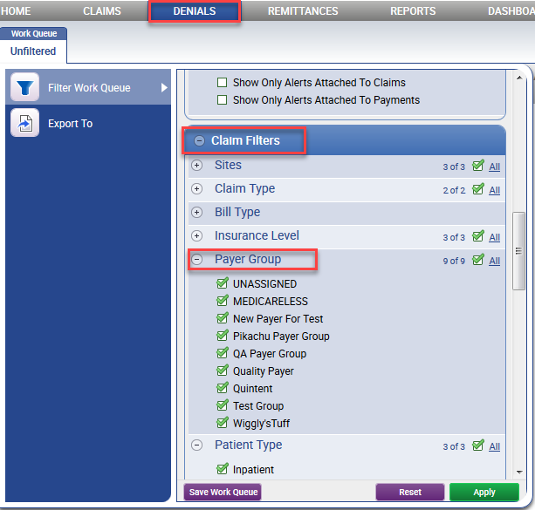

Updated: Follow-Up Detail Report has new parameters
The Follow-Up Detail report has the following new parameters: DRG Code, Procedure Code, Primary Diagnosis, and Category Filter.
