ClaimSource Release Features 7/06/2017
Added: Modifier Description
The modifier descriptions are now shown on the modifiers drop-down lists for both Professional and Institutional forms.
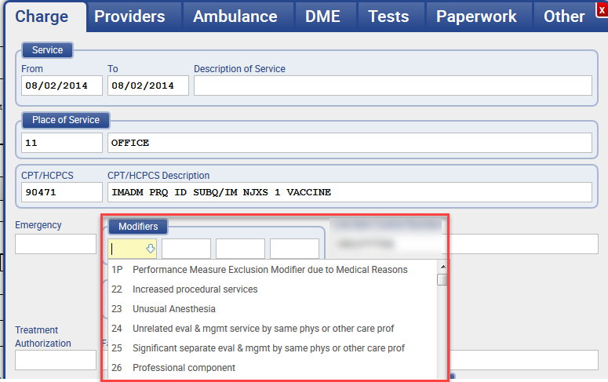

Added: Claim Change History Report on History Window
The Claim Change History report is now accessible from the history window. Users can click the Download History Report button to retrieve the report available in Excel format.
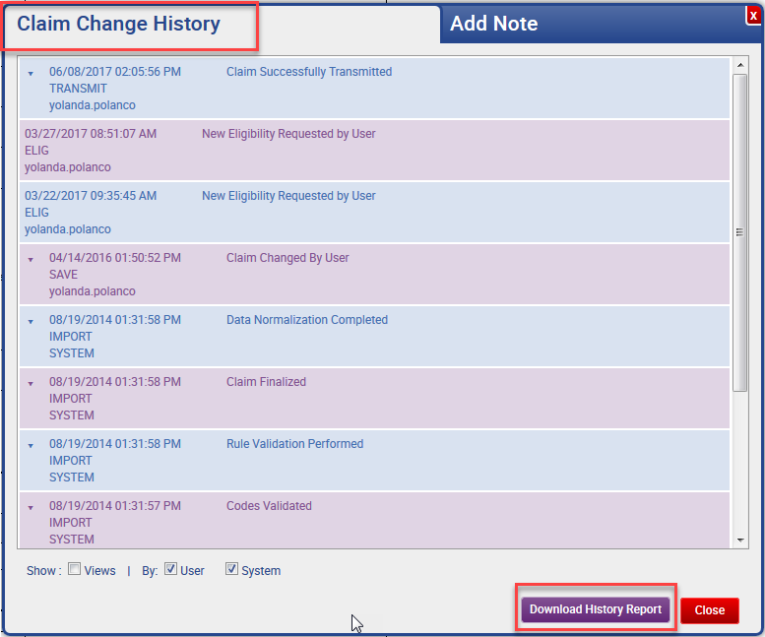

Added: Provider Name Search Filter
Users can search by provider last name or organization. The filter is located within the Organizational Filters on the work queue filter menu. Users can select the provider type if further filtering is needed.
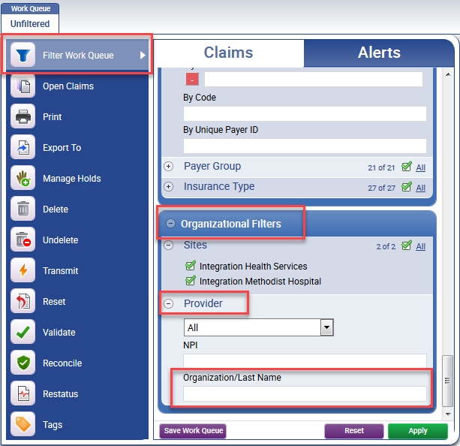

Added: Indicator for Attachments
A new indicator will be displayed for claims with attachments. Attachments taken into account are manually added documents, saved and printed payer/state forms.
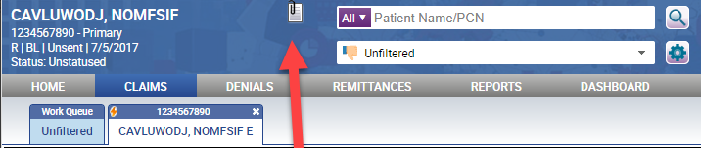

Updated: Combined Claim Detail Report
The Claim Detail Inbound report and the Claim Detail Outbound report have been combined to form a new report called Claim Detail Report. The parameters from these two deprecated reports are now combined into one single report.

Note: Please begin using the Claim Detail Report as the single reports are now considered deprecated and will be removed in the near future.
