ClaimSource Release Features 8/17/2017
Added: NPI Column
A Billing Provider NPI column has been added to both Claims and Alerts work queue. The column can be added by selecting it using the Work Queue Column Settings located in the Queue Manager.
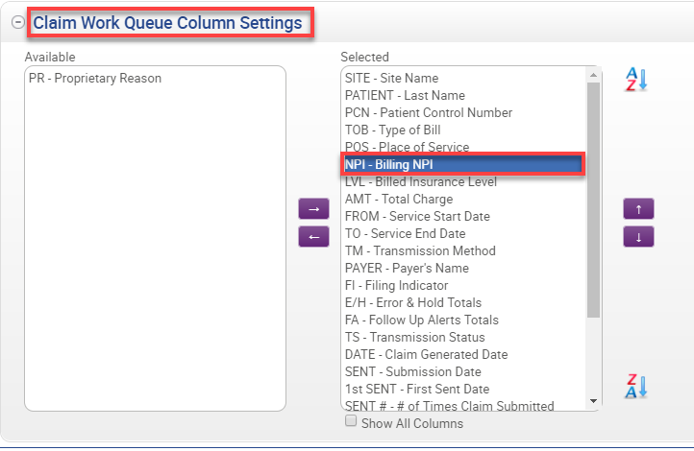

Added: Searchable Hold List
A new search box is available on top of the holds list. Entering information on the search box will narrow down the hold code list matching the description entered.
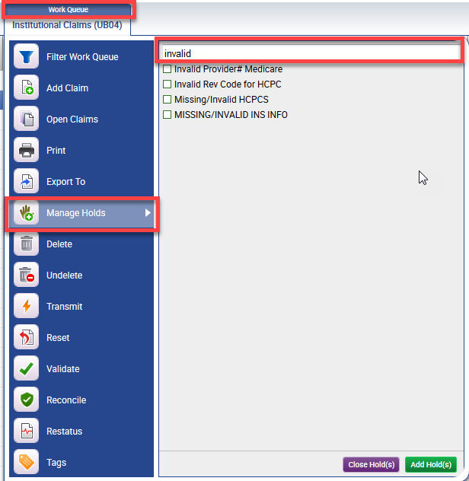

The search box is available in both the Work Queue’s menu and within the claim.
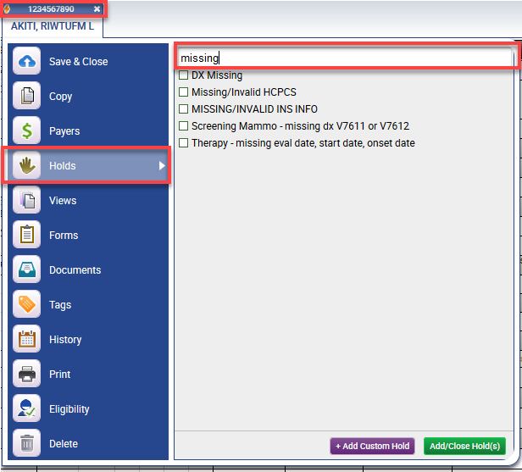

Updated: Print Fulfillment Icon
Claims destined for print fulfillment will now have a new icon to distinguish them from regular electronic claims. The icon is a printer with a lightning bolt on top of it.

