ClaimSource Release Features 9/14/2017

Updated – Error Panel for Ignored Errors
Ignored errors will now only be displayed with the word “Ignored” and the date the action occurred.
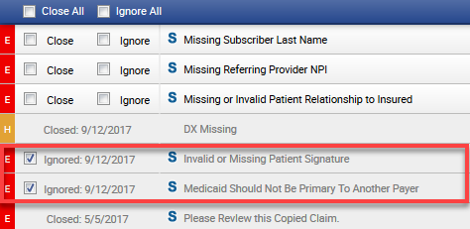

Added – Payer/State Forms TextBoxes
Payer/State Forms free textboxes will now alert the user of the remaining letters allowed to be typed in the field. Users are allowed to enter up to 255 characters.
In the example below, the user can still input 199 more characters.
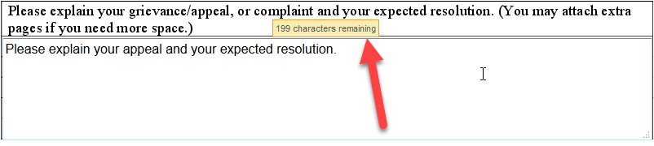

Added: New Report - Claim Totals By Payer Report
A new report has been added to the General Reports section. The report will group the data by payer id. There will be an option to show a breakdown of numbers by all payer records that fall under the same payer id.
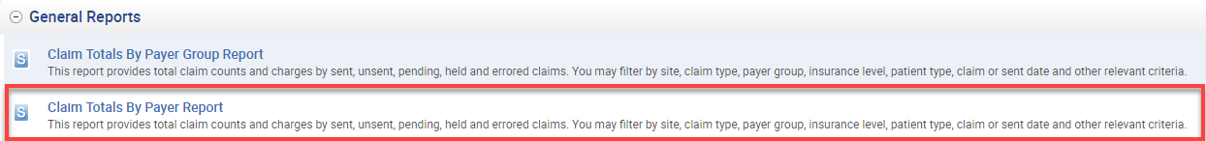

Added – UB04 Rendering Provider Tab
A Providers tab has been added to the Charge window for Institutional (UB04) claims. In the new tab, users may add or edit a line level Rendering Provider.
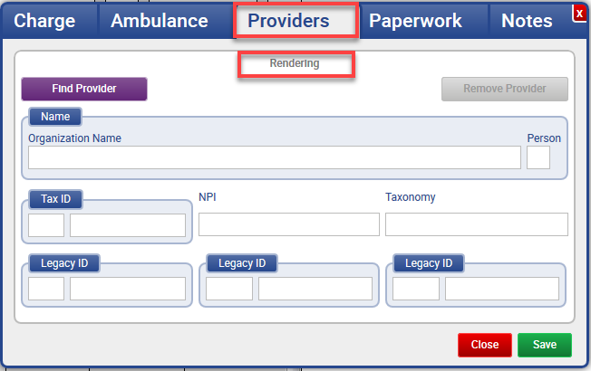

Added - Setup Custom Tables Export/Import
Users with access to the Custom Tables tab in Setup now have the ability to export a custom table. After selecting the table, they will see two new buttons: Export and Import.
After clicking on the Export button, the user can download the template with or without the data.
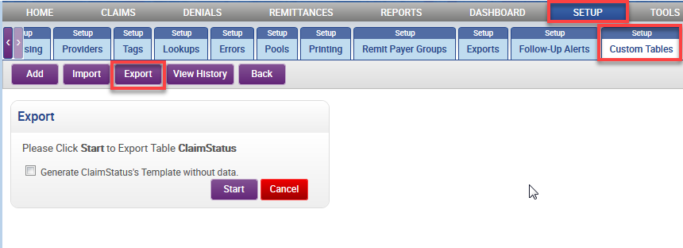

The example below is an exported table without data.
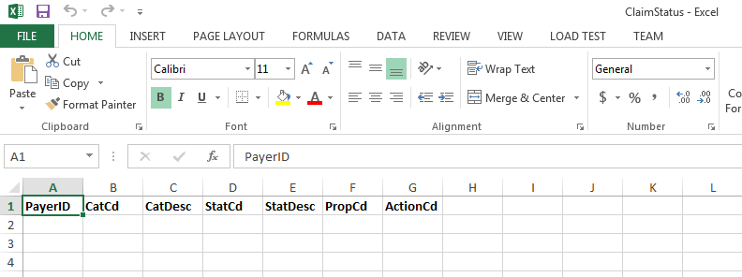

After modifying or adding new data, the user can now import it to the selected custom table. Once the user clicks the import button, they can select the file and click start. The information on the file will either append or overwrite the table with the uploaded spreadsheet, depending if the checkbox to Overwrite is selected.
