ClaimSource Release Features 9/28/2017

Updated: Claims Work Queue Alert Option
The Alert option for Clean Claims has been updated to say “Claims without Open Errors and Holds.” The changed was made to better reflect the logic behind the search.
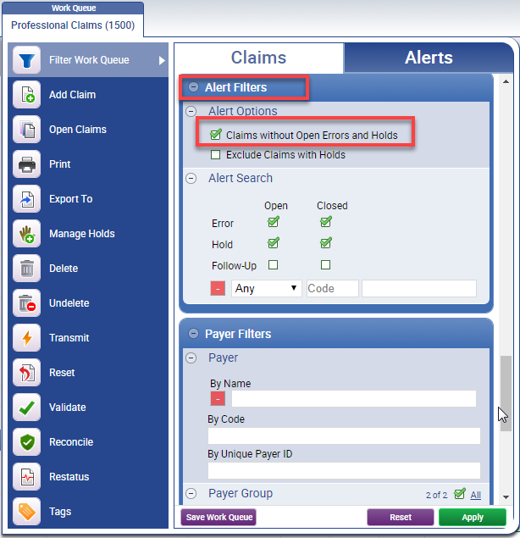
Updated – Claims Detail Report Alert State
The Alert state of Clean Claims has been updated to say “Claims without Open Error and Holds.” The changed was made to better reflect the logic behind the search.
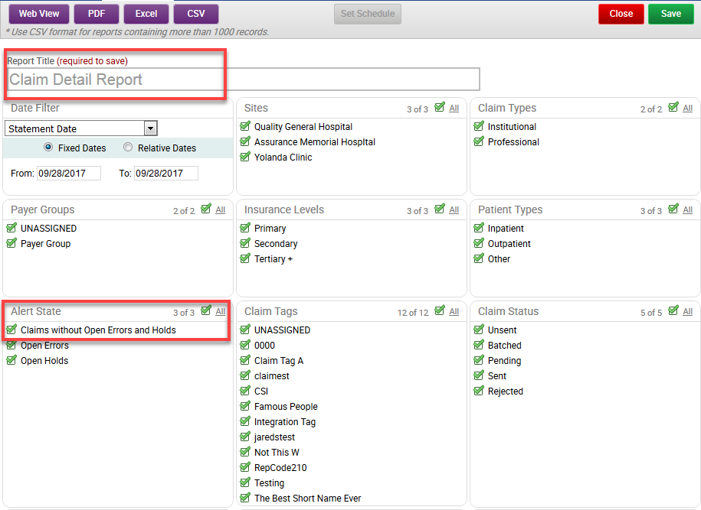

A new option was added to the Additional Filters, Show Only Clean Claims. Clean claims means no errors exist on the claim (unless closed prior to import completing).
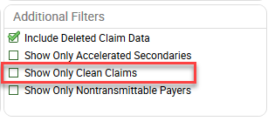
Updated – Denials Work Queue CPT Wildcard or Range Search
An ability to filter the denials work queue by HCPCS/CPT wildcard or range has been added. It will now accept a list of wildcards in the formats of X%, XXX%, XXXX%, XXXXX, or XXXXX-XXXXX.
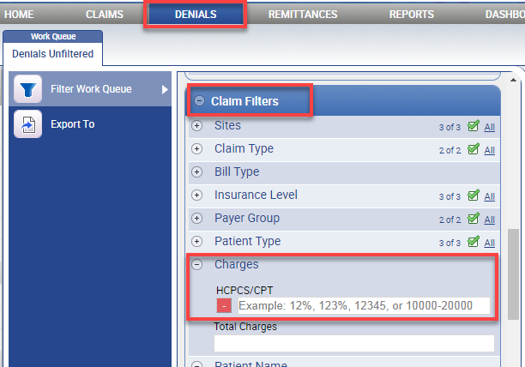
Only the Claim Charges HCPCS/CPT and Remit Charges HCPCS/CPT Searches have been updated.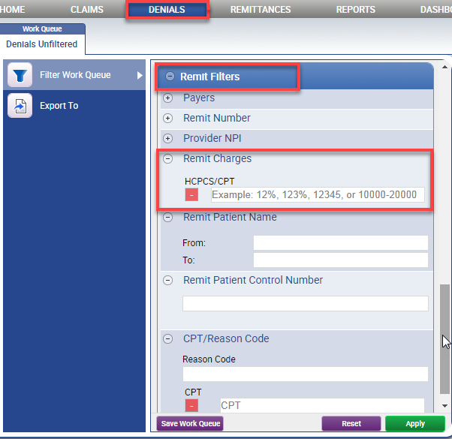

Added – Denials Work Queue Search for a Reason Code and Specific CPT Codes
A filter has been added that requires both a Reason Code and specific CPT codes. The search is for payment lines that have both codes (CPT and Reason Code). The CPT search supports wildcard and range formats of X%, XXX%, XXXX%, XXXXX, or XXXXX-XXXXX.

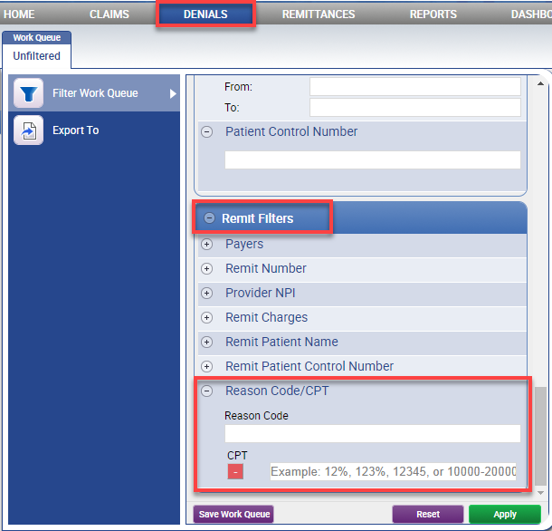

Added - Claim Totals By Provider Report
A new report has been added to the General Reports section called Claim Totals by Provider Report. This report will be grouped by NPI.
