ClaimSource Release Features 10/09/2017
Added – Denials Filters Dx Code, DRG and Procedure Filter
For those clients with Denials, three new filters have been added. User can filter a combination of Diagnoses codes with DRG, Diagnosis Code, DRG Code and Procedure codes.
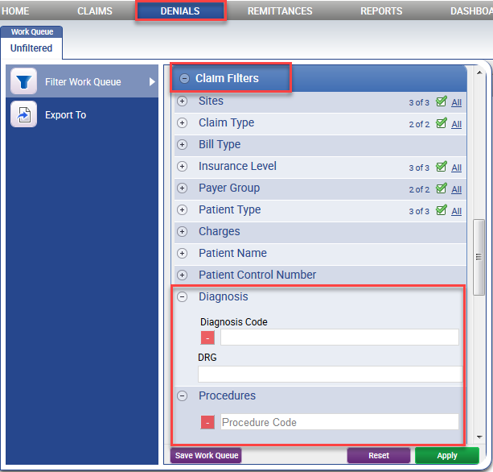

Updated – Rename PayerID to Transmit Code on Reports
The Filter by Payer parameter option of Payer ID has been updated to Transmit Code for better clarification. The output column of Payer ID for those affected reports have also been updated.
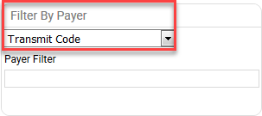
Reports Affected:
Claim Detail by DRG Code
Claim Detail by Procedure Diagnosis Code
Claim Detail by Rev Code
Claim Detail Inbound Report

Claim Detail Report
Claim Error and Hold Detail
Clean Claims Summary Report
Denials by Payer Summary Report
Follow-up Alert Detail Report
Payers Report

