ClaimSource Release Features 10/26/2017

Added – Email and Phone Number Columns to User Setup List
User email and phone number columns have been added to the User Setup list. The columns will also be displayed when exporting the user list to Excel or CSV.
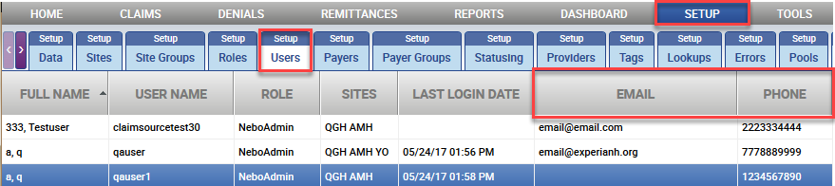

Added – Email and Phone Number Columns to User Report
User email and phone number fields have been added to the Users Report. The users report is accessible through the Reports Security Section.
