ClaimSource Release Features 11/09/2017
Added – Remittance Work Queue
For those clients with Remittances, the option to add work queues has been added under the Work Queue Manager button on the header.
The Remittance Work Queue option is available by clicking the Add Work Queue drop-down list.
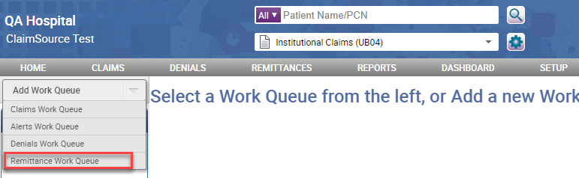
Users will see all saved work queues on the left-side bar under Remittances Work Queues.
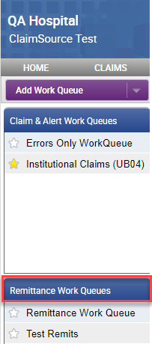

Users can also use the Remittance Search filter to add or modify existing Work Queues by clicking the Save Work Queue button.
Please note: Users can only add Remittances work queues and not Payment Work Queues.
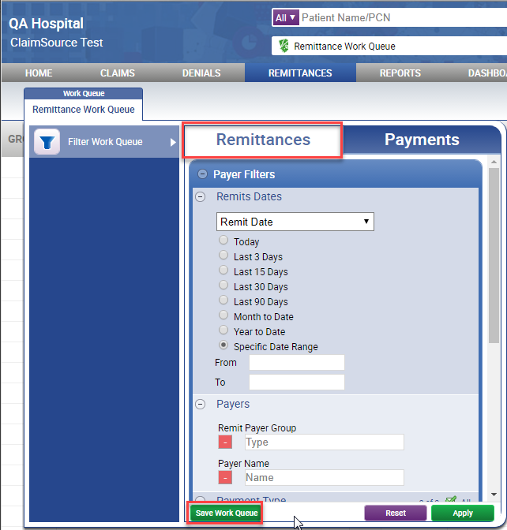

Added – Service Date Range to Copy Claim Option
When copying a claim from the claim maintenance context menu, users can now limit which charges get copied by selecting a date-of-service(DOS) range under the Charges section.
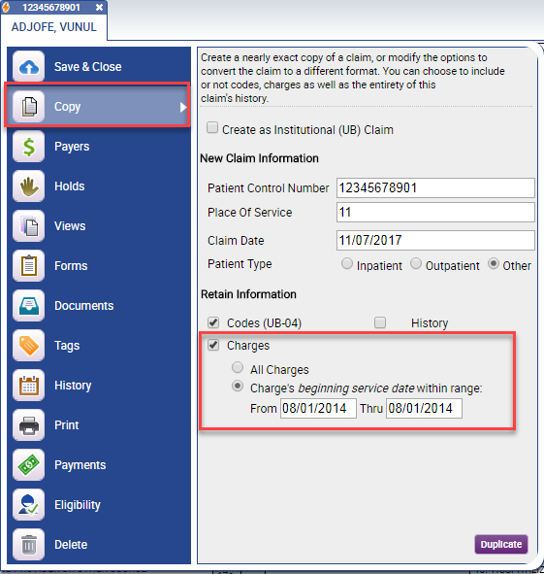

Added – Remit Date Column to Denials Work Queue
For those clients with Denials, a remit date column has been added to the Denials Work Queue. The new column is also available in the Export to Excel/CSV option.
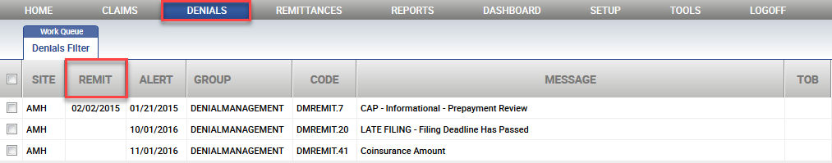
The new column can be added or removed using the Denial Work Queue Column Settings in the Work Queue Manager.
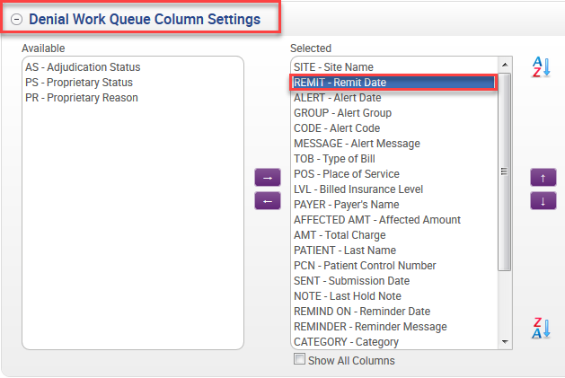

Updated – User’s Phone Number with Dashes
When adding a user’s phone number, dashes will be auto-displayed when entering the phone number.
