***Place your company name*** ***here***. strongly advocates for Electronic Data Interchange standardization and compliance within the healthcare industry. We are committed to promoting and advancing electronic data exchange for the healthcare industry by improving efficiency, advocacy, and education to industry stakeholders and government entities.

**Background**

***Place information on your company here.***

CMS has indicated that the Medicare Eligibility (HETS) system will not be returning the MBI in their eligibility benefit response (271) when the beneficiary has been issued their new number and the inquiry (270) is submitted with the beneficiary’s HICN.  Starting in June of 2018, providers will be able to look up a Medicare patient’s new Medicare number through their Medicare Administrative Contractor’s (MAC’s) secure web portal for the instances in which a beneficiary does not have a new Medicare card at the point of care. CMS believes this tool will give providers a mechanism to access a beneficiary’s MBI securely without disrupting workflow.

**CMS Operational Goals**

CMS’ Primary Operational Goal is:

To decrease Medicare Beneficiary vulnerability to identity theft by removing the SSN-based number from their Medicare identification cards and replace with a new unique Medicare Number.

In achieving this goal CMS seeks to:

* Minimize burdens for beneficiaries
* Minimize burdens for providers
* Minimize disruption to Medicare operations
* Provide a solution to our business partners that allows usage of HICN and/or new Medicare Number for business-critical data exchanges; and
* Manage the cost, scope, and schedule for the project

**Issues Identified with the CMS Approach**

In reviewing the CMS operational goals as it relates to the MBI “lookup tool” that will be supported in the Medicare Administrative Contractor’s (MAC’s) secure web portal, we have identified issues that would increase the burden for providers, including breaking of standard EDI workflow and increasing the administrative cost to the provider.

*Operational impact:*

Providers have expanded their use of automation to manage patient registration and billing. Today providers are working toward “touchless processing” at the point of registration and billing.

Requiring a provider to go outside their normal registration process to obtain the MBI when the patient does not present it will negatively impact the benefits of an automated process.  For every beneficiary for whom the provider does not have the correct MBI, a human will have to manually log on to their MAC’s website to obtain the crosswalk information.  This increases costs and reduces efficiency for providers.

Additionally, systems normally updated with new identifiers utilizing the information returned in the EDI eligibility response will not be updated and additional time-intensive manual effort will be required to ensure proper billing.  Most systems do not map message segments so the communication that there is a new MBI card will not be maintained.

*Cost impact:*

According to the 2017 CAQH Index, the cost for an automated eligibility verification is $0.49. The automation of these processes has allowed providers to redirect personnel costs to actual patient care.

By bypassing the cost limiting the benefits of automated eligibility verification, costs to providers will increase.  CAQH published the cost of a manual eligibility verification to be $8.39. Providers will now not only be increasing the time it takes to register patients and will bear both the automated and manual costs.

*Security and Privacy:*

CMS has stated that the reason for not returning the MBI on the eligibility response is that “returning the MBI when providers submit a HICN gives a higher risk of medical identity theft.”  However, it appears that the risk is no higher when returning the MBI in the eligibility response than via the Lookup tool for the following reasons:

* ***Secure Enrollment for HETS system****:* HETS system users are required to enroll with the HETS system using a valid NPI that is linked to their trading partner who is under contract with HETS - or their clearinghouse, who is under contract with HETS - and must log on with a valid user ID and password, just like for the MAC’s Provider Lookup Tool.  Therefore, unauthorized access to the HETS system is as secure as the portal.
* ***Access to Incorrect Beneficiary Data****:*  The Search Criteria for finding a beneficiary’s eligibility information in the HETS system requires the submission and validation of all of the following information:  the beneficiary’s Medicare ID (HICN or MBI after April 1, 2018), Beneficiary Last and First Names, and Date of Birth.  These criteria are the same for finding the beneficiary in the MAC’s Provider Lookup Tool (except that the tool uses the beneficiary’s Social Security Number instead of the full HICN).  Therefore, there is no enhanced privacy built into the Provider Lookup Tool to prevent retrieval of the wrong patient’s MBI.
* ***Phishing****:* Medicare has operational rules that prevent providers or other unauthorized entities from “phishing” for Medicare identifiers. Per the CMS HIPAA Eligibility Transaction System (HETS) Inquiries Rules of Behavior (10-28-2015), providers who violate the stated HETS usage rules are suspended or lose system access privileges altogether.  Phishing would be no more of an issue when returning the beneficiary’s MBI in the HETS Eligibility response than it currently is today when returning the HICN.

Of note, in the Open-Door Forum for Pharmacy, held on 01/23/2018, CMS indicated that the MBI will be returned in the NCPDP E1 eligibility response.  If the MBI is being returned for pharmacy eligibility requests, it should also be returned for medical eligibility requests.

**Recommendation**

To align with CMS’ goals to minimize the burdens to providers and beneficiaries, we recommend the following:

***When the HICN is submitted in the eligibility inquiry and the beneficiary’s card has been mailed, return the MBI as the Primary Identifier and the HICN as the Prior Identifier.***

The Health Care Eligibility Benefit 270/271 EDI format supports the functionality to return corrected information within the current 5010 standards. We recommend enhancing the HETS 271 EDI response with the following changes:

* New MBI is returned in the in the 271 Response Loop 2100C/2110C NM109 segment when the HICN is submitted in the 270 Loop 2100C NM109 segment.
* REF segment is returned with the Q4 qualifier and the HICN in the REF02 segment.
* INS segment is returned indicating changes in identifying elements from those submitted in the 270.

Example:

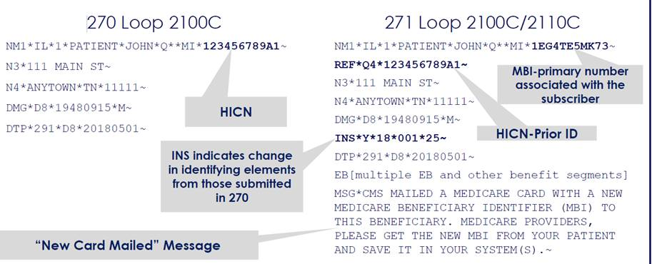

***Recommendation: Provide CMS Clearinghouse Business Partners with a HICN to MBI Crosswalk***

Enhancing the HETS 271 response to include the MBI when the HICN is submitted in the HETS 270 request is critical to ensure a seamless transition. If, however, it is deemed impossible to make this change, some clearinghouses have expressed interest in receiving a HICN to MBI crosswalk. We encourage CMS to consider providing such a crosswalk to interested contracted clearinghouses. Doing so would allow the clearinghouse to enhance provider Medicare eligibility responses where necessary.

In closing, we appreciate the opportunity to provide comments to CMS on the New Medicare Card initiative.

If you have any questions or need additional assistance, please contact;  
**Place your company information here.**